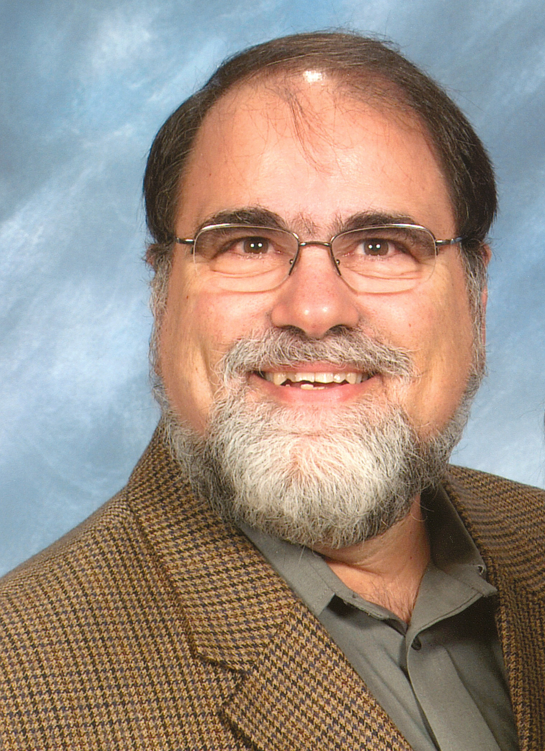**William “Bill” Caroscio**

My journey to become a mathematics teacher was inspired by many of my own teachers. A high school teacher that made mathematics challenging and fun, two ingredients that I strive to incorporate into my instructional practice. Two community college professors were especially helpful in guiding me toward and helping me achieve my career goals of becoming a mathematics teacher.

Upon receiving my undergraduate degree I began teaching Junior High School mathematics in Elmira, New York. I would spend my entire teaching career there. After two years I transferred to one of the high schools in the district where I spent the next 31 years teaching the full gamut of courses from General Math through BC Calculus. I was fortunate to work in a department that included many strong, professional mathematics educators. Along the way I completed a Master’s Degree, earned a certificate in Educational Administration, and took part in a number of mathematical training institutes. It was here that I realized “it is what you learn after you know it all that is really important.”

I began my adjunct teaching career in 1973. I considered myself very fortunate that my second job, something that most young teachers needed, was both personally and professionally rewarding. My experience at three different colleges at both the undergraduate and graduate levels informed my teaching practice and provided many experiences that I could share with my high school students.

Serving for a time as District Chair for Mathematics and Science provided me the opportunity to work with colleagues to improve the instructional program and practices for our district. It was during this time that I became aware of and involved in what would evolve into the T3 – Program, Teachers Teaching with Technology. It was through this program that I learned of the “Power of Visualization!”

One of my most rewarding and challenging experiences was working with the professional organizations AMTNYS and NYSAMS. I was privileged to serve on their executive boards and eventually serve as President of both organizations. Along the way I was provided many opportunities to work with the NYS Education Dept. serving on test writing committees, standards writing committees, and Commissioner’s Panels.

In the early 2000s I was approached by Pearson to become an author for a new project they were starting. This provided a new professional challenge. Never having sat down to a blank piece of paper to write mathematics, other than my tests for students, this proved to be an exciting undertaking. I have had the pleasure of working with two wonderful co-authors in two projects from whom I have learned a great deal.

Upon retirement from the classroom I became a part time consultant for Texas Instruments. This provided me the opportunity to travel around the country working with teachers and students as they try to meet the challenges of the ever changing landscape of mathematics education in the US. I have had the opportunity to work in classrooms from the Rio Grande Valley to Boston, San Diego to Key West. I am continually encouraged by the hardworking students and teachers striving to meet the constantly changing expectations placed upon them.

I thank my wife, Pam, and my daughters, Karen and Elizabeth, for their support in all my endeavors and for their understanding of all the time away my professional activities have required. I thank my students past and present that challenged me as I try to challenge them to be all that they can be. Mathematics is FUNdamental!